The Hunger Games Haggadah

Adapted by Leah Berkenwald with lots of help from JewishBoston.com and Wikipedia.

Seder Plate:

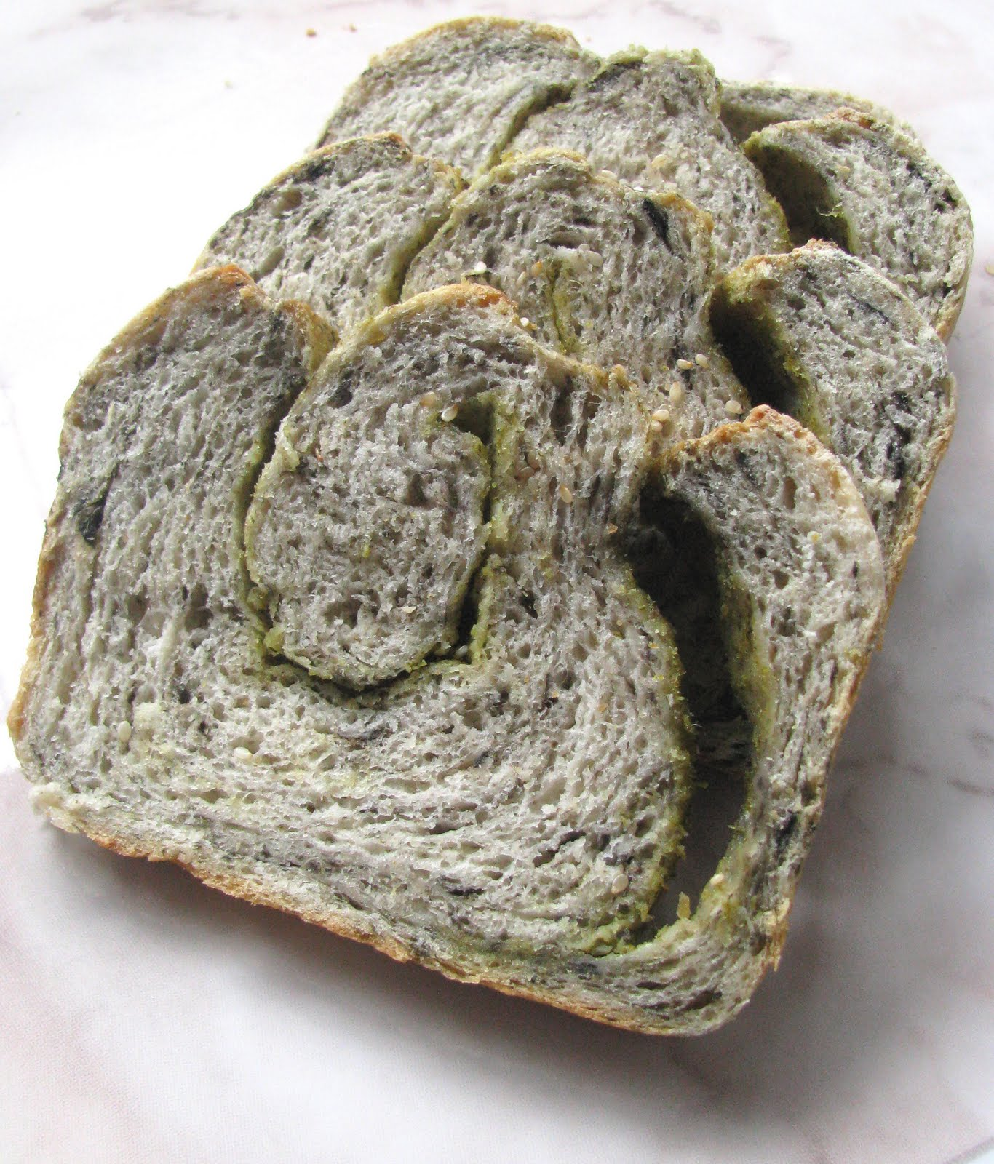
Happy Passover, Panem!
Tonight we gather together to celebrate Passover, our holiday of freedom. We will eat a great meal together, enjoy four glasses (at least!) of wine, and tell the story of Panem’s liberation from the domination of the Capitol.
קַדֵּשׁ Kiddush (the blessing over wine) | kadeish |

We drink the first cup of wine in honor of Haymitch, who was driven to alcoholism by the evil oppression and trauma of the Capitol and President Snow. The wine reminds us that escapism or self-destructive coping mechanisms will not help us in the arena.
We praise Haymitch.
May the odds be ever in his favor!
  - Drink the first glass of wine!
מַגִּידTelling the story of Passover | magid |
  - Pour the second glass of wine for everyone.
The Haggadah doesn’t tell the story of the Hunger Games in a linear fashion.

The Four Questions
Why is this night different from all other nights?
On all other nights, we watch TV. Tonight we talk about the Hunger Games.
On all other nights we drink beer, probably. Tonight we drink four cups of wine because of some reason to do with the Hunger Games.
On all other nights we talk about Harry Potter because it’s awesome. Tonight we talk about the Hunger Games even though it’s great but not quite as great as Harry Potter.

Answering Our Questions
We were slaves. Now we are free.
We were slaves to the Capitol, and Katniss took us from there with a strong hand and outstretched arm. Had she, Peeta, Haymitch, Gayle, and the team from District 13 not brought our ancestors out of brutal oppression, then even today we and our children and our grandchildren would still be tributes.

The Four Children
As we tell the story, we think about it from all angles. Our tradition speaks of four different types of children who might react differently to the Hunger Games story. It is our job to make our story accessible to all the members of our community, so we think about how we might best reach each type of child:
What does the wise child say? The wise child asks, “What are the lessons to learn from the Hunger Games?”
You must teach this child the ways in which this story’s themes of oppression and liberation are applicable to modern struggles in our world.
What does the wicked child say? The wicked child asks, “What does the Hunger Games mean to you?”
To you and not to himself! Because he takes himself out of Panem and misses the point, set this child’s teeth on edge and say to him:
“It is because of what Katniss did for me in the arena.”
Me, not him. Had that child been a tribute, he would have been killed in the opening melee.
What does the simple child say? The simple child asks, “What are the Hunger Games?”
To this child, answer plainly:
“What, do you live under a rock? Go read the books, already.”
What about the child who doesn’t know how to ask a question? Help this child ask. Start telling the story:
“Katniss was a girl who wanted to help her family.”

Telling Our Story (from Wikipedia…)
Our story starts in Panem. Panem consisted of The Capitol, a highly advanced metropolis, that exercised political control over its 12 outer districts. As punishment for a past rebellion against the Capitol, one boy and one girl between the ages of 12 and 18 from each district are selected by an annual lottery to participate in the Hunger Games, an event in which the participants (or "tributes") must fight to the death in an outdoor arena controlled by the Capitol, until only one individual remains.

In District 12 (natural pyramid resources) a young girl named Prim is chosen for the lottery; her old sister Katniss volunteers to take her place. Katniss and Peeta, the male tribute, are taken to the Capitol, where their drunken mentor, Haymitch Abernathy, victor of the 50th Hunger Games, instructs them to watch and determine the strengths and weaknesses of the other tributes. "Stylists" are employed to make each tribute look his or her best; Katniss's stylist, Cinna, is the only person at the Capitol with whom she feels a degree of understanding.

The tributes are publicly displayed to the Capitol audience in an interview with television host Caesar Flickerman, and have to attempt to appeal to the television audience in order to obtain "sponsors". During this time, Peeta reveals on-air his longtime unrequited love for Katniss. Katniss believes this to be a ploy to gain sponsors, who can be critical to survival because of their ability to send gifts such as food, medicine, and tools to favored tributes during the Games.

While nearly half the tributes are killed in the first day of the Games, Katniss relies on her well-practiced hunting and survival skills to remain unharmed and concealed from the other tributes. A few days into the games, Katniss develops an alliance with Rue, a 12-year-old girl from the agricultural District 11 who reminds Katniss of her own sister. In the meantime, Peeta appears to have joined forces with the tributes from the richer districts. However, when he has the opportunity to kill Katniss, he instead saves her from the others. Katniss's alliance with Rue is brought to an abrupt end when Rue is killed by another tribute, whom Katniss then kills with an arrow. Katniss sings to Rue until she dies, and spreads flowers over her body as a sign of respect for Rue and disgust towards the Capitol.

Apparently because of Katniss and Peeta's image in the minds of the audience as "star-crossed lovers", a rule change is announced midway through the Games, allowing two tributes from the same district to win the Hunger Games as a couple. Upon hearing this, Katniss begins searching for Peeta. She eventually finds him, wounded and in hiding. As she nurses him back to health, she acts the part of a young girl falling in love to gain more favor with the audience and, consequently, gifts from her sponsors.

When the couple remain as the last two surviving tributes, the Gamemakers reverse the rule change in an attempt to force them into a dramatic finale, where one must kill the other to win. Katniss, knowing that the Gamemakers would rather have two victors than none, retrieves highly poisonous berries known as "nightlock" from her pouch and offers some to Peeta. Realizing that Katniss and Peeta intend to commit suicide, the Gamemakers announce that both will be the victors of the 74th Hunger Games.

Although she survives the ordeal in the arena and is treated to a hero's welcome in the Capitol, Katniss became a political target after defying her society's authoritarian leaders so publicly. Afterwards, she, Peeta, Haymitch, and others would go on to lead a mass rebellion against the Capitol, eventually overthrowing outlawing the Hunger Games forever.

  - Raise the glass of wine and say:
וְהִיא שֶׁעָמְדָה לַאֲבוֹתֵֽינוּ וְלָֽנוּ.
V’hi she-amda l’avoteinu v’lanu.
Their quick thinking has sustained our ancestors and us.
For not only one enemy has risen against us to annihilate us, but in every generation there are those who rise against us. But Katniss and Peeta saved us from those who seek to harm us.
  - The glass of wine is put down.

The Ten Plagues
As we rejoice at our deliverance from slavery, we acknowledge that Katniss’ and Peeta’s freedom was hard-earned. We regret that freedom came at the cost of their suffering and the suffering of the other tributes. We pour out a drop of wine as we recite each of the plagues.
  - Dip a finger or a spoon into your wine glass for a drop for each plague.
These are the ten plagues which the Gamemakers brought down on the Tributes:

- Forest Fires
- Tracker Jackers
- Muttations (dog beasts)
- Tidal waves
- Muttations (monkeys)
- Blood Rain
- Lightning
- Muttations (Jabberjays)
- Deadly, paralyzing fog
- Mysterious beast of some kind

Dayeinu
The plagues and our subsequent redemption are but one example of the survival skills Katniss and Peeta have demonstrated. Had Katniss and Peeta but survived any one of these trials, it would have been enough – dayeinu.

If Katniss and Peeta had only survived the Hunger Games, that would have been enough!
If Katniss and Peeta had sparked the revolution, that would have been enough.

The Passover Symbols
We have now told the story of the Hunger Games…but wait! We’re not quite done. There are still some symbols on our seder plate we haven’t talked about yet.
The blood-scented rose reminds of the fear Katniss felt while being psychologically tortured by President Snow.
The nightlock berries remind us that when all seemed lost, Katniss found a way to be the master of her own destiny.
The salt water represents the tears of the young tributes, forced to fight to the death. (Some interpretations say it represents the tidal wave of salt water that occurred between 10 and 11 o’clock in the Quarter Quell arena in Catching Fire.)
The seaweed bread represents the contribution and courage of citizens from Districts 4, 8, 11, and 13. (Especially 4, because Finnick Odair is pretty great and has a trident.)
The broth represents the influence of sponsors, a necessary evil in our modern, media-driven, world.
The mockingjay reminds us that small acts of courage can inspire an entire nation.

In Every Generation
In every generation, everyone is obligated to see themselves
as though they personally experienced the Hunger Games.
The seder reminds us that it was not only our Katniss and Peeta that survived; we all survived along with them. However, we must remember that we must take action to save ourselves and others; the odds may never be in our favor.

The Second Glass of Wine
We praise Gayle, who doesn’t get enough credit, for taking care of Katniss’s family while she was in the arena, and for his awesome military skills.
We praise Gayle.
May the odds be ever in his favor!
  - Drink the second glass of wine!
כּוֹרֵךְDipping the seaweed bread in broth | koreich |

We now dip our seaweed bread two times in the hot broth. The seaweed bread represents the sweet support of our friends and allies. The broth represents the support from fickle sponsors. The act of dipping reminds us that in our modern world of reality tv and Kickstarter campaigns, support is complicated and comes from various sources and motives.
שֻׁלְחָן עוֹרֵךְEating the meal! | shulchan oreich |

Enjoy the lamb stew with dried plums! (Katniss’s favorite!) But don’t forget when you’re done we’ve got a little more seder to go, including the final two cups of wine!

בָּרֵךְSaying grace after the meal and inviting Rue the Prophet | bareich |

  - Refill everyone’s wine glass.
We now say grace after the meal, thanking Katniss and Peeta for the food we’ve eaten. On Passover, this becomes something like an extended toast to the rebels, culminating with drinking our third glass of wine for the evening:
May the source of peace grant peace to us, to the people of Panem, and to the entire world. Amen.

The Third Glass of Wine
  - The blessing over the meal is immediately followed by another blessing over the wine:
We praise Cinna, stylist extraordinaire, who reminds us of the power of working within the system.
May the odds be ever in his favor!
  - Drink the third glass of wine!

The Cup of Rue
We now refill our wine glasses one last time and open the front door to invite the spirit of Rue to join our seder.
Rue was awesome and she didn’t deserve to die. She also didn’t deserve all that racist backlash that happened when dumb Americans realized she was black. Anyway, we invite Rue’s pure spirit to join us in this celebration of peace and freedom.

Fourth Glass of Wine
As we come to the end of the seder, we drink one more glass of wine. With this final cup, we give thanks for the experience of reading the Hunger Games Haggadah together, and for the Hunger Games lessons that help inform our daily lives and guide our actions and aspirations.
We praise Suzanne Collins, author of the Hunger Games Trilogy.
May the odds be ever in her favor!
  - Drink the fourth and final glass of wine!

נִרְצָהEnding the seder and thinking about the future | nirtzah |
Our seder is over, according to Panem tradition. As we had the pleasure to gather for a seder this year, we hope to once again have the opportunity in the years to come. As we say…

NEXT YEAR IN DISTRICT 12!

